Surrounding Paracas in A day
Paracas is a beautiful place where you can find a lot of animals such as penguins, sea lions, etc. We were assigned to do a project that involves a trip to Paracas. In groups we have to make many activities according to each subject, also, we were given some instructions and recommendations to take into consideration when travelling. Some of us had good expectations as well as bad ones; others had already visited Paracas and shared their experiences in Paracas to imagine what we would find there. However, the only thing that we were expecting was the day of the trip.
The beginning of the end:
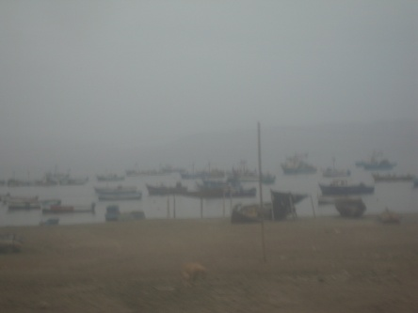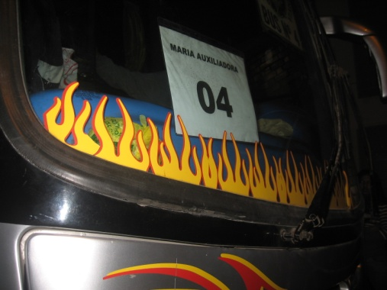And finally the day of the trip arrived! We got together at school at 11:30 on June 9th. We were waiting for the principal to give us some instructions. After that, the leaders of the groups picked up the trash bags for the trip. Then we went into the bus, we sat together as a group, and our parents said goodbye to us through the windows. At 12:30 pm the bus left the school. Then for some reason we had to move to another bus, even though it was late we continued with our journey. On the way some of us were sleeping or taking pictures. This last thing really bothered the police officers because they thought we weren’t taking the situation seriously. In the end we didn’t know the real reasons why we stopped.
We arrived to Paracas at 8:00 am and got into the boat to go to Ballestas Island. On our way to the islands many of us felt sick and almost threw up. But the positive thing of all of this was that we saw a huge variety of animals and dolphins, we learned about some industries in Paracas like Camisea, which is considered threading for environment.
So, we returned to the harbor and then we went to a restaurant to have breakfast. We had bread, tea and juice, while we were having breakfast a group of musicians came into the restaurant and they started to sing songs.
After that, we asked some questions to the habitants of Paracas these questions were about tourism, local economy and historical facts. A lot of people answer the questions but others didn’t know how to answer, but the majority of the people were interested in response the survey. We had little time to buy some souvenirs then we got into the bus and went to “Pisco Plaza” We could see how the city was after the earthquake in 2001 and we saw how the buildings were still destroyed.
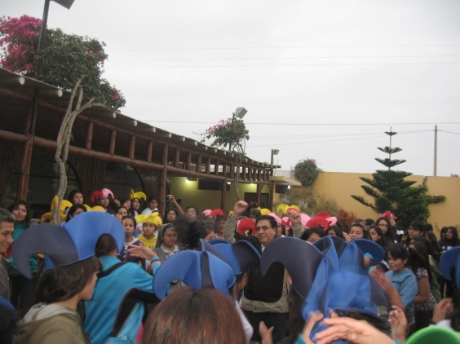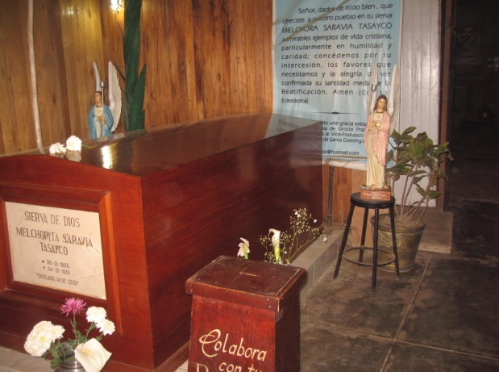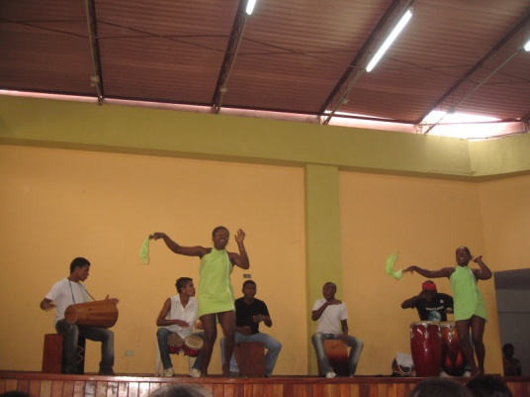Later, we were separated in groups and we started asking again some questions. However, some people refused to answer the questions we gather in Pisco Plaza and went into the bus to go to Chincha and we saw traditional dances performed by Ballumbrosio family. We entered to a building, we sat on the floor and suddenly came out the oldest brother of the Brallumbrosio family; he explained the history of the dances that they were going to perform. Then the dances started which were three. In the end of the presentation, we danced with the performers. We went to the bus we were going to have lunch at Cascabel restaurant. In the way to go there we saw fields where cotton and corn were grown. After one hour and a half we got to the restaurant. We ate Causa y Manchapecho. After having lunch we had like a little party and we played some games. We were divided in groups, 4th grade was in one side and 5th grade was in another one. It was for a dance competition and funny hats were given to us to distinguish groups. In addition teachers joined some groups and as a consequence everything was better and much more fun. When the music stopped, we knew we had to continue with our itinerary so we went to a wine cellar and explained us the process of wine production. Most of us bought wine.
It was almost the end of the journey and our last stop was “Grocio Prado” where Melchorita’s house was located. At Melchorita’s house we learned a lot about her life and her sacrifices, she was really a model of life.
Luckily, we were the only group who found Melchorita’s grave, a very peaceful place and took pictures, it was 6:30 and we got into the buses to go back home and we were so tired that almost everyone fell asleep all the way long Lima. Finally, we arrived at 10:00 at school where our parents were waiting for us and we took there the last pictures to keep the trip in our memories.
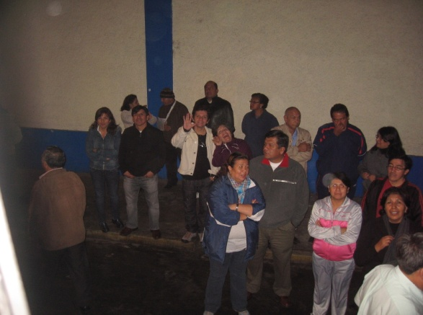We consider that Paracas was a good choice to do the project due to the fact that we learned a lot and we had a great experience many things. Fortunately, we arrived safe and now we have the mission of sharing our ideas to others to appreciate the wonders of Paracas.

Group1: “5to B”
- Victoria Perez
- Stephanie Farro
- Lucero agurre
- Lyssette Vela
- Karen Aguayo
- Lucia Davila
- Ysabo Sifuentes
- Fiorella Pachas
- Laura Cueva

